# CS 255 System Design Document Template

**Alexander Egelston**

## UML Diagrams

### UML Use Case Diagram

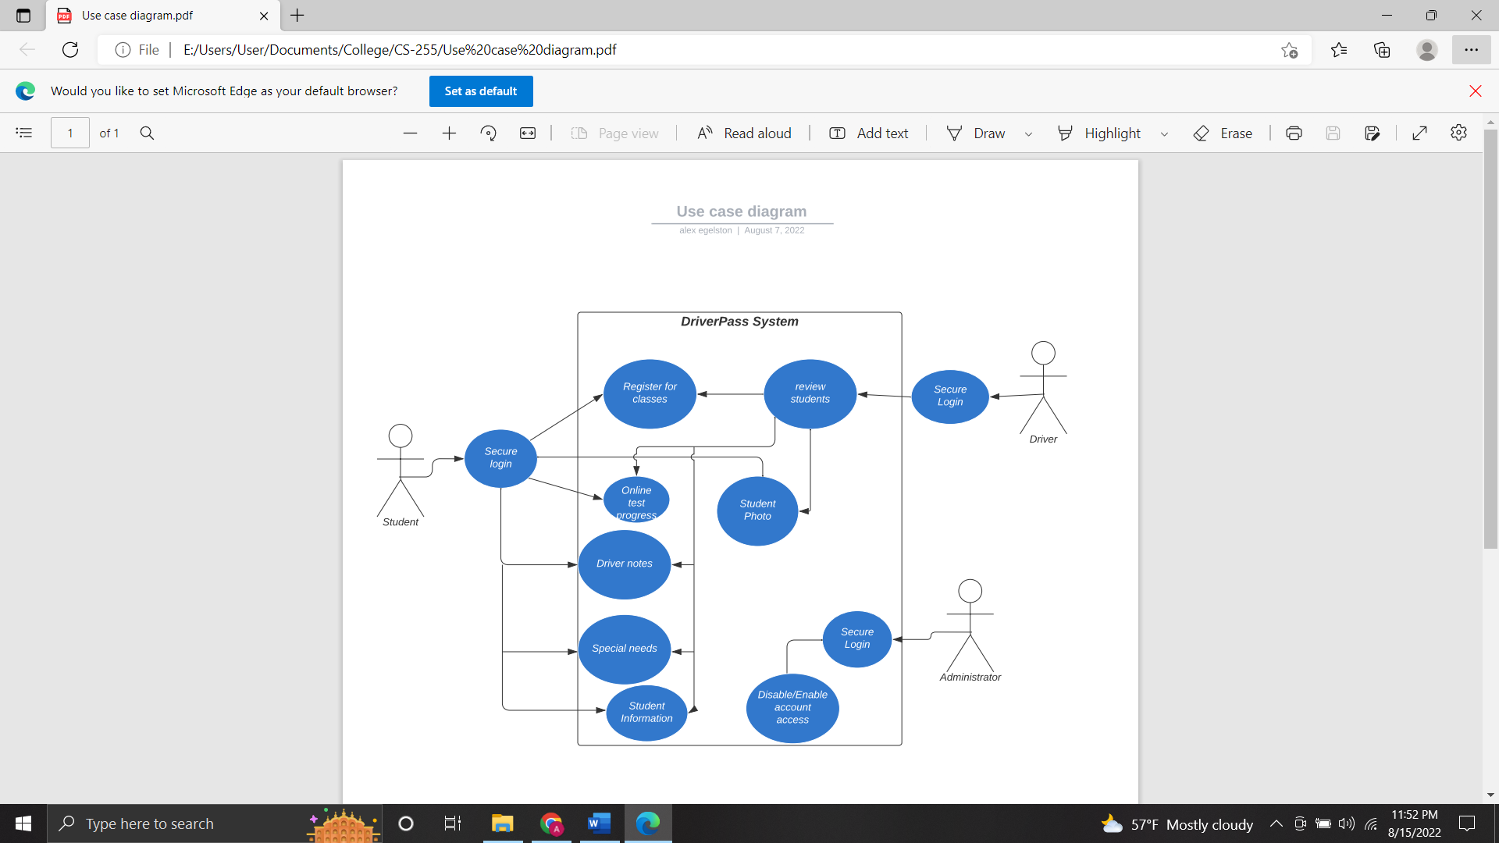

### UML Activity Diagrams

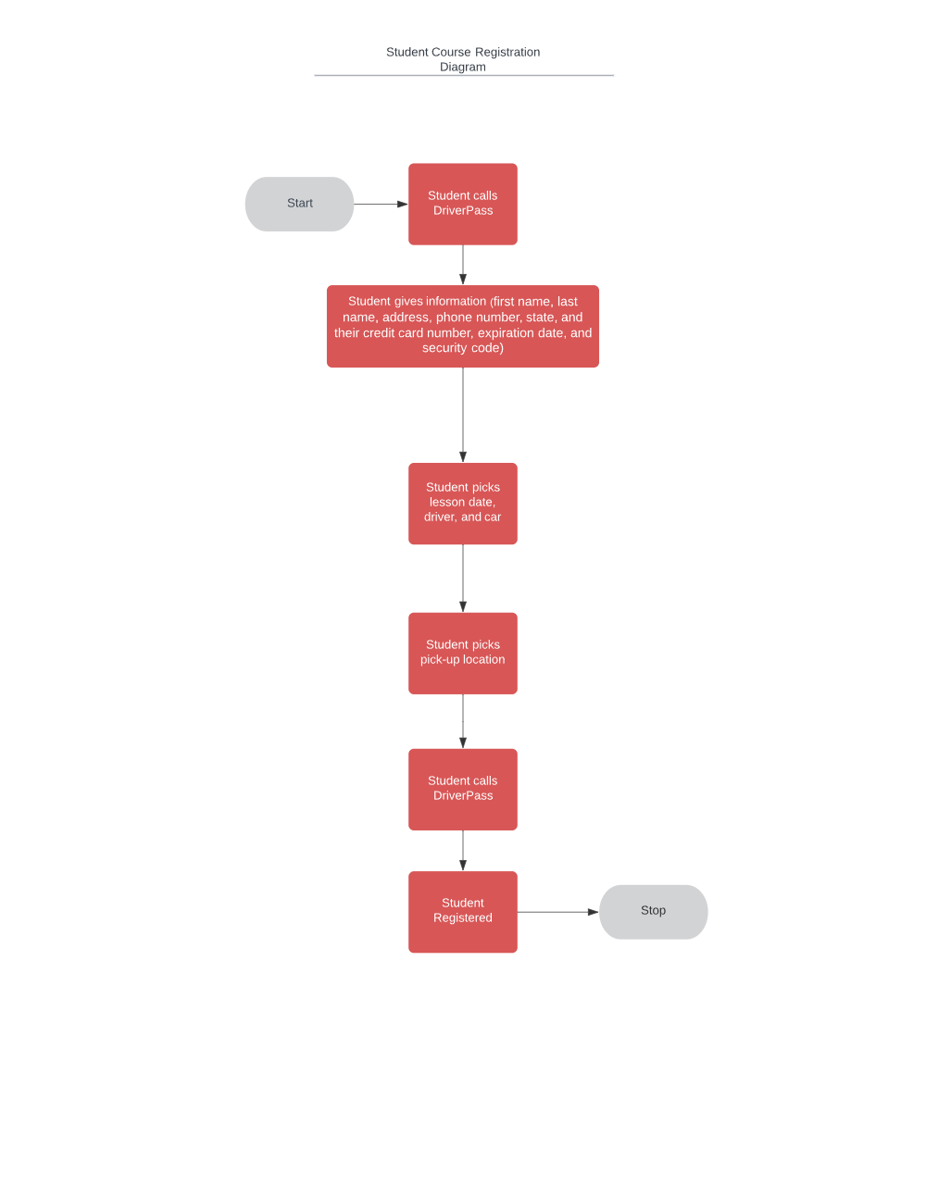

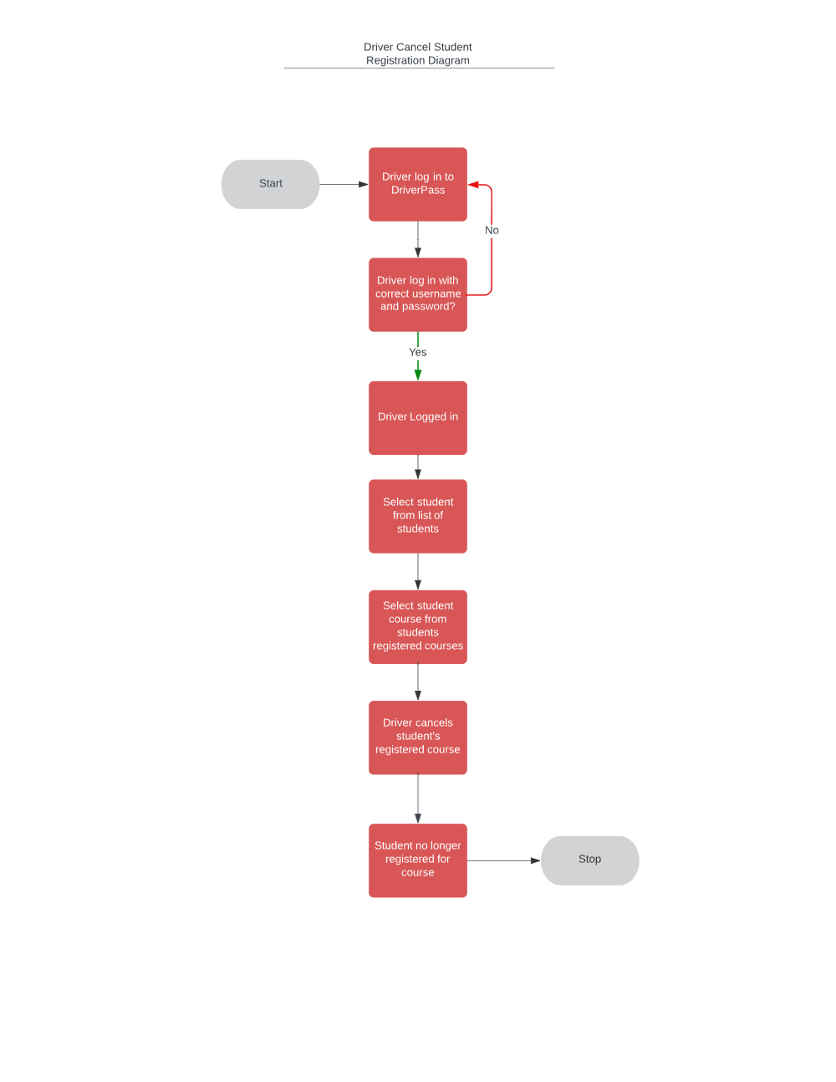

### UML Sequence Diagram

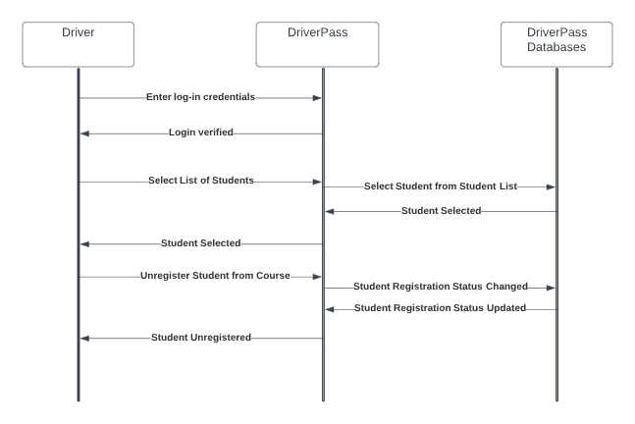

### UML Class Diagram

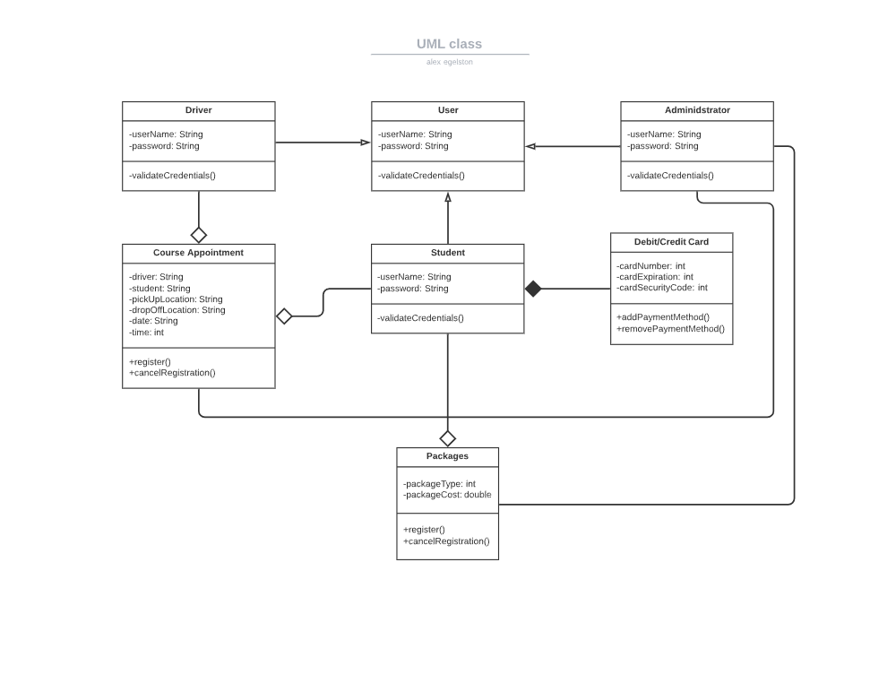

## Technical Requirements

The technical needs of the system interface are accessibility both online and offline, to work for Linux, Windows, and mobile users, be able to accept uploaded data such as student information and class registration, update and display new information such as uploaded data and changes to DMV policy. Each user will need to be able to securely log in to their account and have access to functions that their type of account is supposed to have such as registering for class times as a student account. The system will need to work with the cloud server for storage of user information and course materials and security management. The user will need to be able to interact with the interface with both browsers and mobile applications to ensure offline access as well as online access.